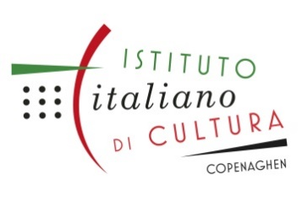 |  | 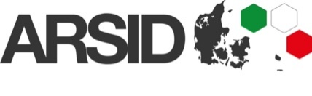

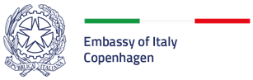
Best young Italian Researcher in Denmark 2022

BIRD Award 2022

V edition

Call for Applications

Deadline: May 2nd, 2022 at 6 pm.

The Italian Embassy in Copenhagen invites young Italian researchers across Denmark to submit applications for its annual research award programme “BIRD Award 2022”, V edition.

The awards will be presented to Italian researchers operating in Denmark who received part of their education in Italy, in recognition of innovative research conducted in each of the three European Research Council (ERC) domains (see ERC Panel Structure 2022):
- Physical and Engineering Sciences (PE)
- Life Sciences (LS)
- Social Sciences and Humanities (SH)

This initiative is coordinated by the Italian Embassy, the Italian Institute of Culture in Copenhagen and the ARSID (Associazione Ricercatori e Scienziati Italiani in Danimarca). The awards will be presented during a ceremony at the Italian Institute of Culture in Denmark on the Italian National Day, in June 2022 (depending on Covid-19 restrictions in place). Winners will be notified by email at least 10 days in advance. Candidates who do not win will be notified as well by email.

Admission Criteria
Candidates must:
  - Possess a valid Italian passport or identity card.
  - Hold academic degree(s).
  - Have obtained the “maturità” or “laurea” in Italy.
  - Be no older than 35 by the application deadline (born after 02.05.1987).
Submission Procedure
Candidates must send a description of the research they have conducted within an academic institution in Denmark, along with a signed copy of the attached declaration from both the candidate and their supervisor (PI) attesting that the results presented for the award were obtained by work conducted mainly by the candidate.
All applications must be submitted in PDF format to the following email addresses: iiccopenaghen@esteri.it and info.copenaghen@esteri.it indicating the subject:
BIRD Award 2022 – Application.
Applicants will receive shortly after an email acknowledging their application has been received. We recommend that prospective candidates read and adhere to the instructions contained in this document to ensure their application’s acceptance. The deadline for applications is by 6 pm on May 2nd, 2022.
Award Process
The evaluation process for applications will be coordinated by the Award Committee of the Italian Embassy which will judge the quality and significance of the research presented. Applications will be assessed within the context of their own ERC domain and a winner will be selected in each of the three ERC domains. The winners will receive an official certificate at a formal ceremony in Copenhagen, as well as have their name published on the Embassy and Italian Ministry of Foreign Affairs’ websites and social media. Winners will also have the opportunity to present their research in a dedicated event at the Italian Institute of Culture in 2022.

The Italian Embassy’s Award Committee

- H.E. Luigi Ferrari, Italian Ambassador to Denmark - President
- Counsellor Antimo Campanile, Deputy Head of Mission, Italian Embassy in Denmark
- Dr. Raffaello Barbieri, Director of the Italian Institute of Culture in Copenhagen
- Prof. Emer. Leonardo De Chiffre, Technical University of Denmark, ARSID President
- Assoc. Prof. Erling Strudsholm, University of Copenhagen
- Assoc. Prof. Enrico Cappellini, University of Copenhagen
- Dr.ssa Letizia Satriano, University of Copenhagen, ARSID Vice-President
- Dr. Francesco Rosati, IV ed. BIRD Winner in Social Sciences and Humanities
- Res. Ass. Lanfranco Pellesi, IV ed. BIRD Winner in Life Sciences
- Dr. Davide Bacco, IV ed. BIRD Winner in Physical and Engineering Sciences

The Award Committee might be assisted in the evaluation by ad hoc External Reviewers.

BIRD 2022 – Application Form

Applicant name:

Applicant date of birth:

Contact Details

Telephone:
Postal Address:
E-mail:

Research domain (Tick appropriate box):

  - Life Sciences
  - Physical and Engineering Sciences
  - Social Sciences and Humanities

Research Title:

Institution in which research was conducted:

Please further attach (in English):

- “State of the Art” - Statement on the status of the research field. (Max 1000 characters including spaces)
- Statement of research results. (Max 2500 characters including spaces)
- Statement on the impact of the research and its implications for the state of research in its field. (Max 1500 characters including spaces)
- A signed copy of the attached declaration (See Attachment 1)
- A brief Curriculum Vitae (See Attachment 2)

Attachment 1 Declaration

With reference to the attached application for the BIRD Award 2022, I confirm that the results presented here are the result of work principally conducted by the applicant, and were obtained at the listed institution.

Institution where the research was conducted:

Date:

Applicant signature: Supervisor signature:

Full name (Printed): Full name (Printed):

Attachment 2
Curriculum Vitae

Applicant name:

Education

Bachelor’s Degree in (fill only Master’s degree category below in case of Single Cycle degree):

Thesis title:

Institution:

Master’s Degree in:

Thesis title:

Institution:

PhD/Doctorate:

Thesis title:

Institution:

Current Position:

Name and address of contact institution:

Awards and acknowledgments:

List of Publications (Max 5):

Place and Date: Full name (Printed):

